Different Types of Athabascan Shelters

http://www.ankn.uaf.edu/curriculum/athabascan/athabascans/alaskanathabascans.html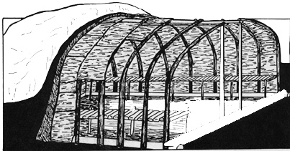

During the long, cold winters some Athabaskans lived in houses built partially underground. Others lived in rectangular log houses with sod roofs. Still others lived in dome-shaped structures covered with caribou or moose skin or sewn birch bark. They constructed their summer houses of birch bark. For temporary camps the Athabaskans built small shelters of brush or birch branches.
https://sites.google.com/site/alaskanativesathabaskan/professional-statement/experience-2
